GIT TUTORIAL

Git is used to upload our programs or projects and track changes in files typically In software development Projects.

There are several steps to upload a project,

**Step 1:** First of all,Create a new repository ,



Step 2: Give a name to the repository and give name,



Step 3: Create a folder which we want to upload……

Step 4: Open the compiler in side the file and initialize the git using “git init”

Step 5: Next Add the file using “git add .”

Step 6: Then, commit using “ git commit -m “first” ”

Step 7: Then add origin, of repository

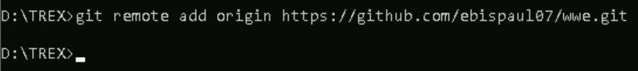

Step 8: Then , push the code to the main tree…

Step 9 : Then, your project is successfully uploaded….

